Excel Data Analysis Project

# 1. Project Overview

### **Project Title**: US Debt Tracker

### **Author**: Adnan Aslam

### **Tools Used**: Microsoft Excel 2021

## Summary

This personal project involves analysing public and governmental debt using a publicly available dataset to showcase my data analysis skills. The analysis focuses on identifying trends and patterns in the data, providing insights that could inform future decision-making regarding debt management. Through this project, I demonstrate my ability to conduct exploratory analysis and create clear visualizations.

Objective:

The objective of this project is to analyse historical data on US public debt to uncover significant trends and insights that can inform policy decisions and debt management strategies.

Stakeholders:

The primary stakeholders for this analysis include government officials and policymakers who require accurate data and insights for effective debt management, as well as the general public interested in understanding national debt trends.

## Key Questions:

1. What was the Yearly Debt Percentage Increase for each year compared to the previous year?
2. Which months historically have seen the highest/lowest increases in Total debt?
3. What is the projected growth of the publicly held debt in the next few years?

# 2. Data Collection & Understanding

Data Source: Public Dataset

Data Type: Time Series

## Data Description:



## Initial Observations:

The dataset reveals several important patterns:

Data Structure:

Organized in row format with three rows for different entities and multiple columns for each date, which may require reshaping for analysis.

Debt Values:

Presented in scientific notation, which can be confusing; conversion to standard number or currency format will enhance clarity.

Missing Values:

Contains null and blank entries that may affect analysis accuracy; addressing these is essential for reliable results.

## Limitations & Assumptions:

Data Structure:

The row format with multiple columns for dates may require reshaping for specific analyses.

Missing Values:

Missing or blank entries are considered random, and imputation or exclusion methods may introduce some uncertainty.

Scientific Notation:

Debt values in scientific notation are accepted as accurate, with conversion to a standard format intended to enhance understanding.

Dataset Completeness:

The analysis relies on the completeness of the dataset; missing data for certain periods may limit trend identification.

# 3. Data Cleaning and Preparation

The dataset required minimal cleaning as it was mostly well-structured. The primary transformation involved converting nulls into empty cells, debt values from scientific notation to a standard number format, and removing unnecessary decimal points (which were zeros). No further significant cleaning was necessary.

# 4. Analysis Strategy

# Exploratory Data Analysis (EDA)

## Exploratory Approach:

Missing Records:

There is no data for public or intragovernmental debt from 1993 to 1996.

Inconsistent Data Frequency:

From 1996 to 2000, there is only one record per year. The data frequency increases between 2000 and 2004, with 4 to 12 records per year.

Consistent Tracking:

From 2005 onwards, the dataset maintains around 191 records annually, indicating consistent tracking until 2022.

2023 Data:

There are only two months of data available for 2023, which will be ignored due to its incomplete nature.

Weekly Gaps:

Data is missing for two days each week, likely Saturdays and Sundays, suggesting no weekend tracking.

EDA Visualizations:

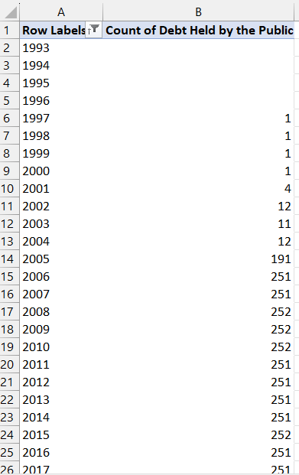

## Key Insights from EDA:

The dataset contains consistent and reliable records from 2006 to 2022, with 250 or more entries per year, making it suitable for detailed analysis. However, the lack of sufficient data from 1993 to 2004 may limit accuracy if this earlier period is included in the analysis.

# 5. Analysis and Findings

## **Methods Used**: Table, Pivot Table and Charts.

## Results:

Finding 1:  
The most notable year was 2020, when U.S. debt spiked by 19.60% due to the combined impact of the U.S.-China trade war (2019) and COVID-19 recession.

Finding 2:  
Debt tends to rise from November to February, driven by end-of-year government spending and preparations for the new fiscal year. Conversely, debt growth slows from April to July due to increased tax revenue and reduced spending.

Finding 3:  
From 1993 to 2006, debt remained under $5 trillion, then gradually increased to $17 trillion by 2019. It surged to $22 trillion in 2020 and is projected to reach $33 trillion by 2027.

## Key Insights:

* The trade war and COVID-19 drove a notable debt spike in 2020.
* Debt fluctuations align with government fiscal cycles, increasing in winter and stabilizing in spring/summer.
* Long-term debt trends show consistent growth, with projections of continued acceleration.

# 6. Interpretation and Business Impact

Impact on the Common American Citizen:

Higher taxes or reduced government services:

As the national debt grows, the government may increase taxes or reduce spending on public services like healthcare, education, and infrastructure to manage the debt burden.

### Inflation and cost of living:

The consistent rise in debt, particularly during times of crisis like COVID-19, could lead to inflation, which increases the cost of everyday goods and services, making it harder for families to afford necessities.

### Increased borrowing costs:

As national debt grows, interest rates might rise, making mortgages, car loans, and credit card interest more expensive for citizens. This would directly impact the financial stability of American households.

These effects show how government debt trends can translate into higher living costs and financial pressures for the average American.

# 7. Recommendations

Reallocate Spending:

Redirect funds from non-essential programs to critical areas like healthcare, education, and infrastructure that directly benefit citizens.

Increase Fiscal Oversight:

Implement stricter budget oversight to reduce wasteful spending and limit unnecessary debt accumulation.

Manage Debt Efficiently:

Explore refinancing debt at lower rates and introduce policies to gradually reduce reliance on borrowing.

Improve Transparency:

Encourage public involvement in fiscal decisions to ensure spending aligns with citizen priorities.

# 8. Challenges and Limitations

### Incomplete Data:

The dataset lacks consistent records from 1993 to 2004, which limits the accuracy of historical debt analysis.

### Random Missing Data:

Certain days are missing, affecting the continuity of some monthly analyses.

### External Factors:

Unpredictable global events (e.g., COVID-19) may have significantly skewed debt trends, making it harder to predict future patterns with certainty.